**SORTING AND GROUPING DATA**

**-- Create Country table with fields: Id ,Country_name ,Population & Area**

CREATE TABLE Country (

Id INT PRIMARY KEY,

Country_name VARCHAR(50),

Population BIGINT,

Area INT

);

DESC country;

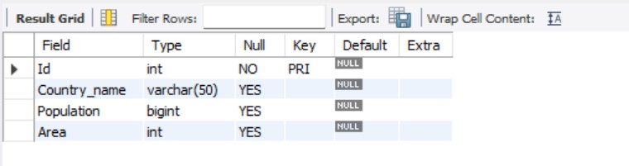

**-- Create persons table with fields: Id ,Fname, Lname, Population, Rating ,Country_Id & Country_name.**

CREATE TABLE Persons (

Id INT PRIMARY KEY,

Fname VARCHAR(50),

Lname VARCHAR(50),

Population BIGINT,

Rating DECIMAL(3, 2),

Country_Id INT,

Country_name VARCHAR(50),

FOREIGN KEY (Country_Id) REFERENCES Country(Id)

);

DESC persons;

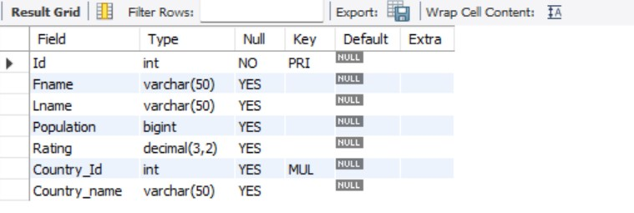

**-- Insert data into Country table**

INSERT INTO Country (Id, Country_name, Population, Area)

VALUES

(1, 'USA', 75000000, 9833520),

(2, 'India', 5000000, 3287263),

(3, 'Canada', 8000000, 9984670),

(4, 'UK', 150000000, 243610),

(5, 'Australia', 400000, 7692024),

(6, 'Germany', 2000000, 357022),

(7, 'France', 6900000, 551695),

(8, 'Brazil', 6000000, 8515767),

(9, 'Russia', 15500000, 17098242),

(10, 'Japan', 8650000, 377930);

select * from country;

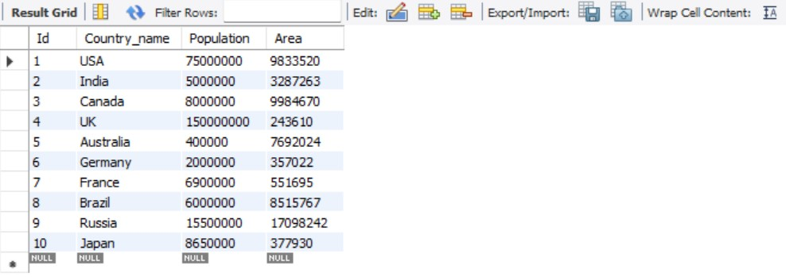

**-- Insert data into Persons table**

INSERT INTO Persons (Id, Fname, Lname, Population, Rating, Country_Id, Country_name)

VALUES

(1, 'Jeeva', 'Joseph', 75000000, 4.5, 1, 'USA'),

(2, 'Arya', 'Shan', 5000000, 3.8, 2, 'India'),

(3, 'Emma', 'Emmi', 8000000, 4.9, 3, 'Canada'),

(4, 'Basim', 'Johny', 150000000, 4.2, 4, 'UK'),

(5, 'Aryan', 'John', 400000, 3.9, 5, 'Australia'),

(6, 'Maria', 'Grace', 2000000, 4.7, 6, 'Germany'),

(7, 'James', 'Wilson', 6900000, 2.1, 7, 'France'),

(8, 'Suzzy', 'Martin', 6000000, 4.0, 8, 'Brazil'),

(9, 'Robert', 'Williams', 15500000, 1.7, 9, 'Russia'),

(10, 'Jane', 'Taylor', 8650000, 4.6, 10, 'Japan');

select * from persons;

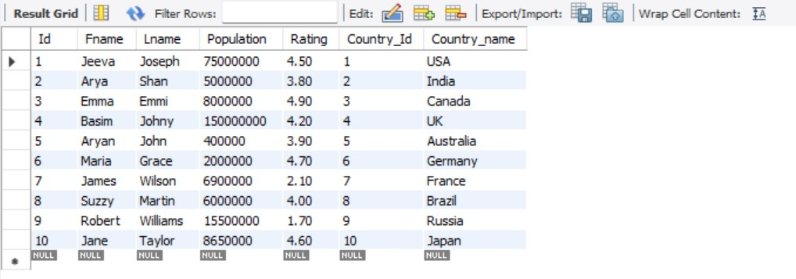

**-- (1) Write an SQL query to print the first three characters of Country_name from the Country table.**

SELECT LEFT(Country_name, 3) AS First_Three_Chars FROM Country;

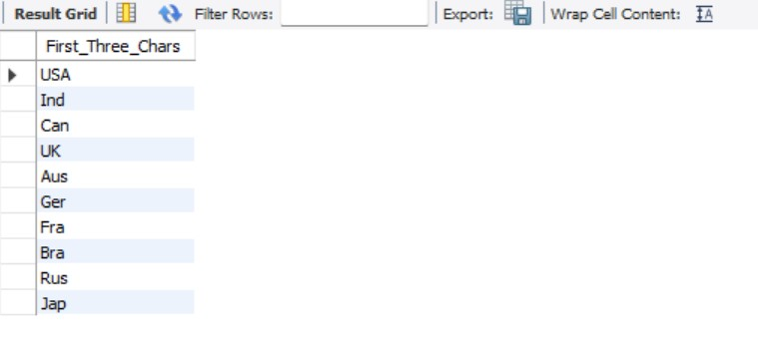

**-- (2) Write an SQL query to concatenate first name and last name from Persons table.**

SELECT CONCAT(Fname, ' ', Lname) AS Full_Name FROM Persons;



**-- (3) Write an SQL query to count the number of unique country names from Persons table.**

SELECT COUNT(DISTINCT Country_Id) AS Unique_Country_Names FROM Persons;



**-- (4) Write a query to print the maximum population from the Country table.**

SELECT MAX(Population) AS Maximum_Population FROM Country;



**-- (5) Write a query to print the minimum population from Persons table.**

SELECT MIN(Population) AS Minimum_Population FROM Country;



**-- (6) Insert 2 new rows to the Persons table making the Lname NULL. Then write another query to count Lname from Persons table.**

INSERT INTO Persons (Id, Fname, Lname, Population, Rating, Country_Id,Country_name) VALUES

(11, 'Aishwarya', NULL,75000000, 4.5, 1, 'USA'),

(12, 'Daisyy', NULL, 15500000, 1.7, 9, 'Russia');

SELECT * FROM persons;

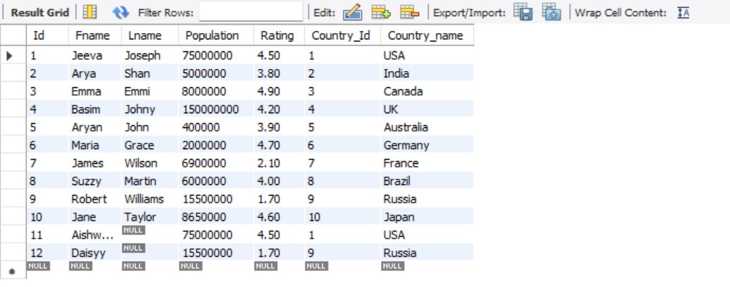

SELECT COUNT(Lname) AS Count_of_Lnames FROM Persons;



**-- (7) Write a query to find the number of rows in the Persons table.**

SELECT COUNT(*) AS Total_Rows FROM Persons;



**-- (8) Write an SQL query to show the population of the Country table for the first 3 rows. (Hint: Use LIMIT)**

SELECT Population FROM Country LIMIT 3;

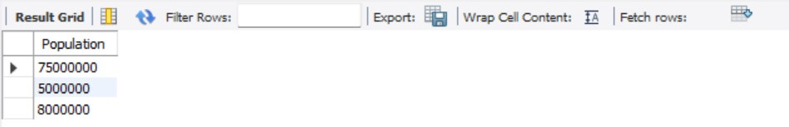

**-- (9) Write a query to print 3 random rows of countries. (Hint: Use rand() function and LIMIT)**

SELECT * FROM Country ORDER BY RAND() LIMIT 3;

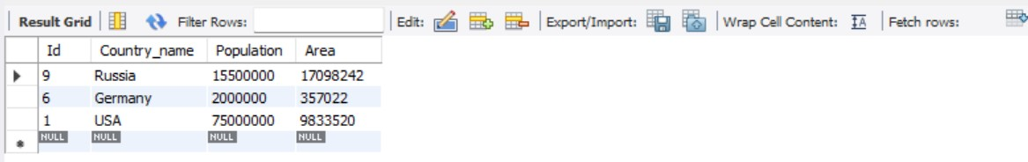

**-- (10) List all persons ordered by their rating in descending order.**

SELECT * FROM Persons ORDER BY Rating DESC;

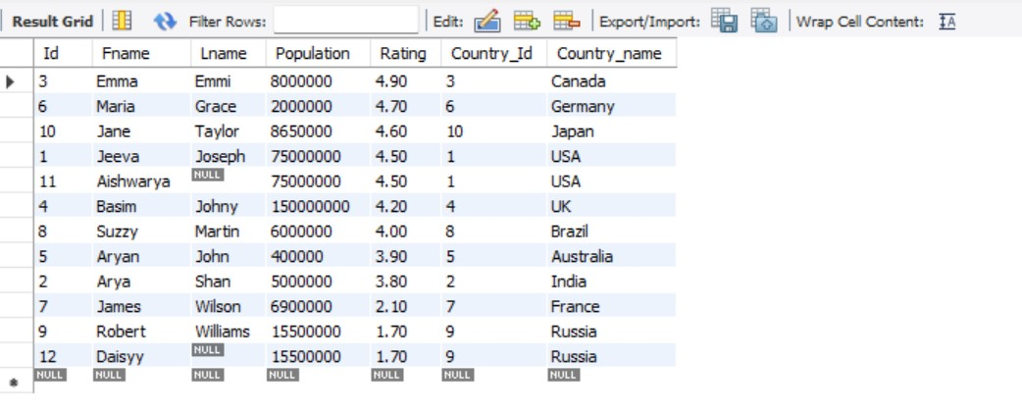

**-- (11)Find the total population for each country in the Persons table.**

SELECT Country_name, SUM(Population) AS Total_Population FROM Persons GROUP BY Country_name;

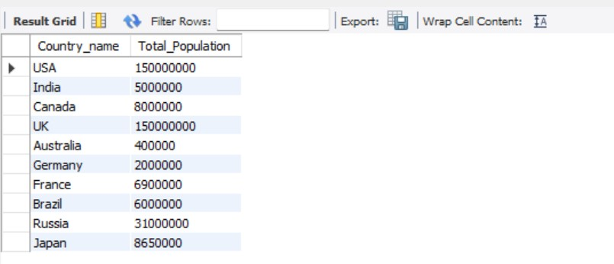

**-- (12) Find countries in the Persons table with a total population greater than 50,000**

SELECT Country_name FROM Persons GROUP BY Country_name HAVING SUM(Population) > 50000;

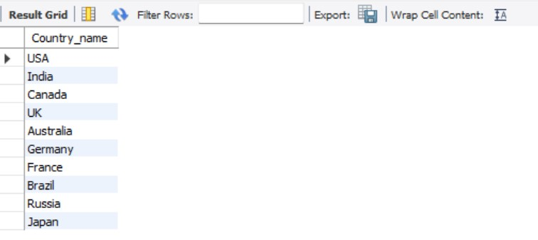

**-- (13) List the total number of persons and average rating for each country, but only for countries with more than 2 persons, ordered by the average rating in ascending order**

SELECT Country_name, COUNT(Id) AS Total_no_of_Persons, AVG(Rating) AS Average_Rating

FROM Persons

GROUP BY Country_name

HAVING COUNT(Id) >2

ORDER BY Average_Rating ASC;



-- List the total number of persons and average rating for each country,

but only for countries with 2 or more persons, ordered by the average rating in ascending order

SELECT Country_name, COUNT(Id) AS Total_no_of_Persons, AVG(Rating) AS Average_Rating

FROM Persons

GROUP BY Country_name

HAVING COUNT(Id) >=2

ORDER BY Average_Rating asc;

